Short Stories & Verses

by

John Timbers

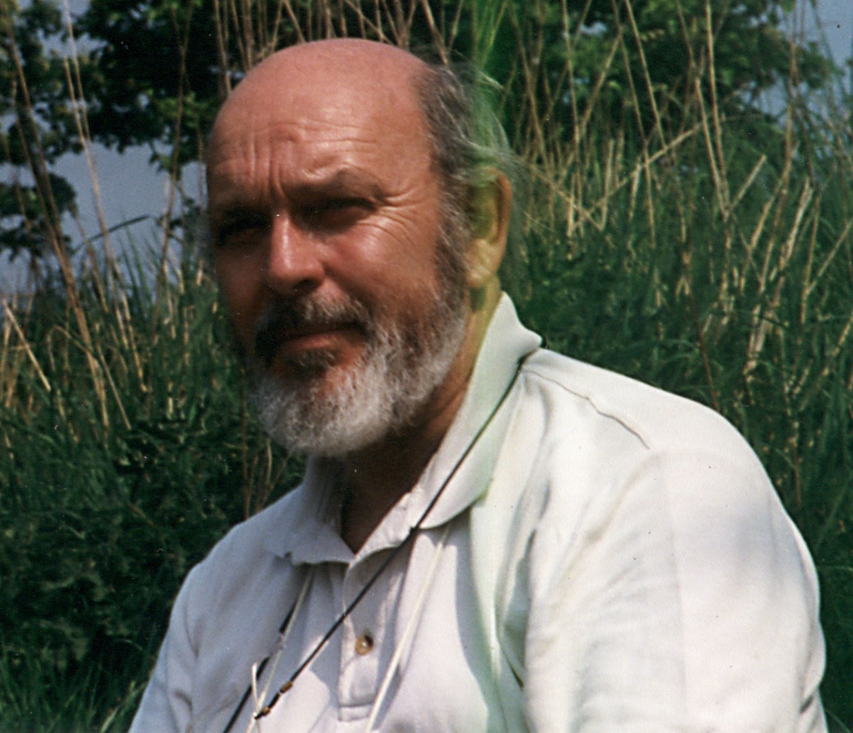

By the Same Author
Historical Fiction:
The Rutilius Journals:
- Caesar's Tribune
- Master of Gaul
- Albion Ablaze
- A View to a Death
- The Road to the Rubicon
- Caesar's Tribune – The Whole Story (a compendium of the five books above)
Science Fiction:
The Think Freedom Trilogy:
- Think Freedom
- Time Marches On
- The Next Generation
A Personal Memoir:
- The Sandpiper Sagas
Non-Fiction:
- A Taste of Ancient Rome
Translations:
Caesar's Commentaries On His Campaigns
- De Bello Gallico
- Bellum Civile (incorporating De Bello Alexandrino, De Bello Africo and De Bello Hispaniensi)

Short Stories & Verses

by

John Timbers
©2016 John Timbers
All rights reserved.
This book or any portion thereof may not be reproduced or used in any manner whatsoever without the express written permission of the publisher except for the use of brief quotations in a book review.

Contents
Short Stories & Verses
by
John Timbers
By the Same Author
o Bellum Civile (incorporating De Bello Alexandrino, De Bello Africo and De Bello Hispaniensi)
Short Stories & Verses
by
John Timbers
Contents
Puss in Boats
An Ode To Fidelity
Beam Me Up…
The Lady in Red
Epilogue
The Broken Leg or
Be Careful What You Wish For
Drinkies Time!
Eternal Love
The prose from an undisclosed poem:
the challenge? To put it back into a poem:
Night Sky at Jaisalmer
Night Sky at Jaisalmer
Camouflage
Quotation from Lucretius
(anonymous translation into English from the original Latin)
Lucretius - On Fear of Death
Spectral Dimensions
Love’s last journey
Practice Piece
This is a fragment inspired by the Think Freedom Psi-fi Series

Puss in Boats
HAVE YOU EVER been on a ship and watched the grace and independence of those affectionate and often useful creatures, ships’ cats? Or observed with amused amazement the incredible, sure-footed antics of a marina moggy, disdainfully defying mere man’s attempts to make life difficult, as it purposefully heads for shore over a tangle of rigging, mooring lines, sails and other assorted paraphernalia? I have––often––and, being an ardent fan, I have frequently admired their incredible adaptability. So, when a problem arose at home about who was going to look after Mr Jinks, while we went sailing for the week-end, I had no doubts about the answer––none. It all started because of that nasty ginger tom next door. Before the arrival of Mr Jinks, he had been as nice as pie. He had treated our house as a second home; lavished affection on us––never a hint was there of the truly evil nature lurking beneath that lovable, furry exterior. Dormant beneath that gorgeously soft, marmalade fur coat, behind that deceptive, purring display of affection, lay a heart eaten up with jealousy and possessiveness.
Mr Jinks was a very different person – I mean cat – altogether. I am sure it will not offend his long departed soul if I describe him as a first cross Siamese/Alley cat, thirteen––pounds of long, lean, tabby, with friendly habits and infinite patience. He was and always had been since kittenhood, used to travelling. He moved house with my brother––a military man of nomadic nature––more often than most, and accepted change, not always without typically Siamese vocal protest––as part of the cross a well-bred feline has to bear for putting up with people. He came to live with us simply because he didn’t fancy going to Germany. It was not so much the going as much as the coming back––all that nausea about immigration and quarantine just did not appeal.
Minutes after Mr Jinks’s arrival chez nous, Huntley, the megalomaniac moggy next door, appeared on the garden fence, as was his wont, looking through our large French window, making little mewing sounds. I went to greet him, as was my wont, and, reaching up to fondle his ears, was savaged for my pains. Thereafter he waged a constant war on the whole family, sidling up to one or other of us in pretence of seeking company and affection, then striking with unsheathed claws and vanishing before retribution––in the shape of my boot––could catch up with him.
To return, however, to my original theme: that Summer I bought, in a fit of enthusiastic light-headedness, a yacht––nothing big and flashy, you understand, but one of those increasingly popular, week-end “trailer/sailers”. Mr Jinks became a weekend grass widow/cat. The neighbours, bless them, were more than happy to pop round and feed and let him out from time to time––at first. But their Machiavellian moggy was not without influence. The week-end came when the neighbours apologetically let it be known that, because of the strange behaviour of their own cat, they would––albeit reluctantly––have to cease their humanitarian efforts on Mr Jinks’s behalf. Of course, everyone else in the neighbourhood had dogs, and the nearest cattery was miles away, and––to be honest–fiendishly expensive.
So it was decided, without prior consultation, alas, that Mr Jinks would go to sea.
**********
The Friday afternoon toil ground to a close and I roared home––well, no, let’s be honest––I limped home on my rather sick Lambretta as fast as its flat-out 30mph would take me, ready to zoom off to the marina in the ready-loaded car.
The house was deserted. The French windows stood wide open and there, in the middle of the lounge, stood Mr Jinks’s travelling basket, its wire mesh door ominously open. The reason was plain enough. I knew we should not have discussed our plans in front of him. He had done this before, for despite his wide experience as a traveller, the truth was that he didn’t like cars. Outside in the garden, was the assembled family––wife pleading; elder daughter scolding, and younger daughter and son giggling––all vainly trying to persuade Mr Jinks to come down off the high, plank fence.
Half an hour later, a disgruntled tabby and a dishevelled bunch of determined mariners set out in the family estate car, crammed as usual to the gunwales with sailing gear and victuals for a week-end afloat. The patient military out-flanking manoeuvre to capture our recalcitrant feline crew-member was forgotten with much laughter. The south cones flying from the imaginary mast of Mr Jinks’s basket were ignored. We interpreted the deep-throated yowls––even a half Siamese doesn’t merely miaou––as complaints, not threats.
Take it from me; take the trouble to learn Yowl. It is a language well worth listening to carefully.
**********
Having loaded our jaunty little vessel, The Sandpiper, with assorted chandlery and goodies, the press gang returned ashore to carry its feline victim, bound and struggling aboard––well no. It was not quite like that. Mr Jinks, now sporting a natty collar and lead––he submits to such indignity with an almost dog-like patience––permitted himself to be led as far as the jetty. After a token, indignant struggle, he allowed himself to be carried on board, and quite soon seemed to resign himself to his new surroundings, even venturing topsides to take a disapproving stroll along the narrow deck to the fo’csle and back. Before long, he had ensconced himself below on a pile of bedding, contentedly watching as we stowed ship and prepared for a night at our moorings.
A small occasional four-berth yacht can be very cramped if a family of five is not well organised. Now veterans of at least four weekends, we had stowage down to a fine art. The inventive mind, born of necessity, had redesigned the fruits of an earlier enthusiasm––a snappy blue and orange, continental frame tent, into a rather snappy, tailored boom-tent, complete with zip-fastening flaps, to cover the entire cockpit. Here slept the three children, mercifully still conveniently small at 7.2, 4 and 3.2, while the captain and his lady slept below in the privacy of the comparatively spacious cabin.
Our lavatorial arrangements were adequately catered for both ashore and afloat, but what of Mr Jinks? Black Mark! His catnip tray had been left behind in the rush and we could hardly put him ashore in a strange marina and honestly expect to see him again. Dilemma – a night walk on a lead and hope that his doggie propensities would stretch to such indignities? People must have thought we were mad––perhaps they were right.
The morning’s efforts were no more successful, but with a glorious day promising ahead, the problem was shelved. Puss, showing no particular signs of distress, was returned without further complaint on board, where he partook of a hearty breakfast, alongside his ravenous messmates.
The Sandpiper was soon cleared for action. Warps were singled up, and the small, throaty outboard motor burst into life most satisfactorily on the first pull of its lanyard. Alas, sensitive as he was to noise at the best of times, the roar of the engine reverberating through the fibreglass hull was just too much for Mr Jinks. Quick as a flash, he leapt from his comfortable cushioned seat in the cabin, from which he had been watching with superior disdain our bewildering antics, and shot aft under the starboard cockpit seat. There he burrowed into the rolled sleeping bags and his own blanket and refused to come out for anybody. No adventure-loving moggy he.
Dismissing this cowardly desertion of his post as a fairly typical reaction from our feline freebooter––he is a fearsome, blood-lusting monster to small birds and mice, but just watch him run when mighty-moggy next door comes on the scene––I turned my attention to manoeuvring The Sandpiper down-river towards Poole Harbour.
Once clear of the narrow river Frome, we hoisted the mainsail and disconnected the fuel line from the outboard to let it run dry. Still no sign of Chicken Cat, despite the silence topsides. The Sandpiper heeled to a light breeze and surged forward on her best point of sail – a broad reach.
**********
Each of us in turn tried to persuade Mr Jinks of the joys of sailing, but no amount of cajolery would persuade him to abandon his cosy nest in the darkest depths of the starboard quarter berth. A more determined attempt by the skipper led to armed defiance of authority––twenty very nasty looking claws were unsheathed. Always a great believer in that old adage about discretion and valour, I retreated hastily, assuring the anxious family that he would get used to it as the day wore on.
Giving the crew strict orders not to fraternise with the mutineer, I dismissed him from mind and applied myself to enjoying a brisk run out to the harbour mouth, passing north of Brownsea Island and showing a saucy, clean pair of heels to all but the much larger vessels abroad on that perfect Summer’s morning.
**********
A gusty force 2 to 3 sou’wester carried us jauntily over the wake of the receding chain ferry and out over the sand bar at the harbour mouth. At once the sea grew choppier and The Sandpiper surged forward under full furling genoa and main, breasting the short sparkling waves in company with a veritable flotilla of assorted sailing craft bound for the Solent or Chichester no doubt on the East-bound tide.
To say that the family consists of one hundred percent staunch sailing aficionados would be to stretch the truth somewhat. Needless to say, I am an enthusiast from way back in Sea Cadet days. The distaff side is loyal, almost to a fault, but a decidedly devout fair-weather girl. Number-one daughter is definitely Daddy’s girl, while number-two daughter stands well to the left of Mama and tolerates Pa’s mad, maritime ways for her sake only. The youngest man of the house certainly enjoys messing about in boats, but has, I fear, a sneaky admiration for those nasty buzzy little powerboats that make any true sailor’s hackles rise. And Mr Jinks? Not for him the joys of wind ruffled fur and spray-spangled whiskers; not for him the feline contemplation of the medium of his favourite dish. Oh, no! Huddled below in his misery, he defied all efforts at mediation and plotted dark revenge, his green eyes and bared teeth glistening each time one of us dared disturb his self-imposed solitary confinement.
Unrepentant, but not wishing to alienate his affections further, we reluctantly decided to cut our day’s sailing short, abandon our customary seamanship lessons, and return to one of our favourite mooring spots in the mouth of the Frome, which we had christened the US Barges, off Hamworthy. Once there we could anchor for a quiet swim and renew our efforts to persuade Puss to make the most of his holiday afloat.
Taking advantage of our vertically rising drop-keel, we anchored in rather less than two feet of water off a sandy beach. To our left grew a low copse of mixed birch and dwarf oaks, while in front of us and to the right stretched a wilderness of tufts of wiry grass, interspersed with clumps of gorse and bramble thickets. While the children enjoyed themselves paddling through the black ooze, hidden by a thin layer of golden sand, the galley slave whisked together in her usual efficient fashion the ingredients of a delicious and filling late lunch.
Meanwhile, I attempted yet again to coax poor Puss out of his lair, my fear for the bedding not being the least among my motives. The sound of a tin-opener on his favourite proprietary brand of cat food failed even to raise a whisker. This was not going to be easy.
“Daddy, can we take Jinksy ashore to do his business?”––very earthy-minded was number-one daughter then––come to think of it, still is.
“Well, I suppose so, but we’ll have to persuade him to come out of hiding first. Let’s have lunch first. Perhaps he’ll have simmered down a bit by then. I think he’s gone off us in a big way for the time being.”
This agreed, we all set to, sitting in the open cockpit in glorious sunshine, our plates on our laps. We all fully expected this to be too much for Mr Jinks, who had never been known to miss an opportunity to beg for scraps. Not a bit of it. Clinging grimly to his sulks, he remained in self-imposed solitary below throughout the meal, ignoring all attempts to mollify his outraged dignity. No way was he going to let us off the hook. Guilty we felt and guilty he meant us to feel.
**********
Have you ever tried digging a wildcat out of a hole in which it is determined to stay? I don’t recommend it as a sport. However, miraculously with only one small scratch for my pains, I did manage to do so after a prolonged and wary battle of wits. Triumphantly, I waded ashore with my seething bundle gathered securely in my arms, both front and back paws firmly imprisoned in my fists.
With the family gathered in a semi-circle, I set Mr Jinks, wriggling madly, down onto the silver sand on his four paws, half expecting him to go down on his knees and kiss the blessed sod. Not he––dropping into his ‘I’m the great hunting cat’ pose, he belly crawled up the beach into the long grass at high speed. We were all caught on the hop by the sudden movement, and it was with something bordering on panic that we saw his tail disappear between two tussocks of spiky grass. Bounding up the foreshore, I was just in time to see him dive for cover into the tangled depths of a bramble bush with the biggest thorns I had ever seen. Our half-amused concern for poor Mr Jinks now turned to fear––fear that we might not be able to catch him again. This genuine concern for his safety was not unmingled with a certain regard for my own. Our peace-loving domestic pussycat was now undeniably a wild animal. The snarls and hisses issuing from the depths of the tangled bramble vines were unmistakably hostile.
All at once it was all rather serious. The game was over. I deployed the family around the bush, warning them sharply that they were under no circumstances to attempt to recapture Mr Jinks if he should try to make a break for it. Trying to display more calm than I actually felt, I began to pick my way gingerly towards the centre of the tangle, where he was defiantly hurling abuse at me with a vehemence that was terrifying.
At last, scratched from head to foot by the thorns, I prepared to grab the snarling, fierce and suddenly very big wildcat, his ears laid back against his head, teeth and claws bared ready for a fight. And a fight it was to be, with no holds barred. A thirteen-pound cat is no mean adversary, I can assure anybody who might be tempted to scorn my efforts. I bear the scars to this day where his teeth and claws found their mark in my unprotected hands and arms. It took me more than a split second to forget that this was my soft, cuddly puss-cat. With several round military oaths – for which I was later taken to task, I might add – I fetched Mr Jinks a couple of smart, open-handed clouts––cruel, no doubt, but in extremis, very necessary. The struggle was brief but bloody, and it was my blood that stained the silver sands in fair quantity before Mr Jinks was returned, still spitting with rage, to his hidey-hole at the foot of my berth.
**********
Waiting only long enough to bathe my wounds and bind them up with the entire supply of bandages in our first-aid kit, we weighed anchor and motored back up-river. Our light-hearted attempt to convert our home-loving, mixed-up moggy into a ship’s cat was over. My one aim now was to return him to house and hearth before anyone else could fall victim to his bloodlust.
Leaving the family aboard The Sandpiper, I transferred Mr Jinks – miraculously without sustaining any further wounds––to his travelling basket, and, with fingers fast swelling in their bandages, drove him home as fast as the law would permit. Arrived back at the house, I opened the basket with some trepidation. With studied nonchalance, Mr Jinks emerged, rubbed himself against my leg and stalked off into the kitchen, looking over his shoulder at me with that expression I had long since come to understand: “Follow me. I’m hungry and it’s time to feed me.” Happily I complied and, after a few strokes and more pleased rubbings, I left him to his supper and returned to the bosom of my anxious family, a happier and wiser man, having been firmly put in my place.
Now, I know, just as surely as if he had told me, who is boss in our house. No he doesn’t wear pants, just a superior Cheshire Cat smile.
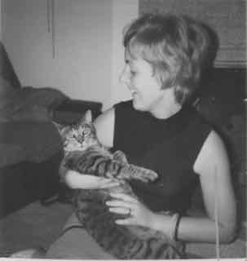

An Ode To Fidelity

Twenty-six years we’ve been wed
And we neither have strayed from our bed:
No amours, no affairs,
No adulterous pairs,
Nor anything else – be it said.
Just think what we’ve missed, mistress mine,
To never have drunk of that wine,
That lovers enjoy –
Lovely girl, handsome boy –
When their beautiful bodies entwine
What? Do you say it is better to miss,
Than betray with a sweet unchaste kiss?
Would you pointlessly weep
If I once chose to sleep
With a beauty who promised me bliss?

Why so selfish to rob me of pleasure?
Is fidelity so harsh a measure
That it must deprive
Me, whose soul comes alive
When I contemplate such illicit treasure?
But then would I feel quite so at ease
If you were a temptress or tease?
Could I sit idly by,
And gaze up at the sky,
While you tested my love by degrees?
No! Lust is my fantasy game,
Far from real and decidedly tame.
For bare maids I may sigh,
Streaming past my mind’s eye,
But in your eyes I gaze without shame.
29 November, 199
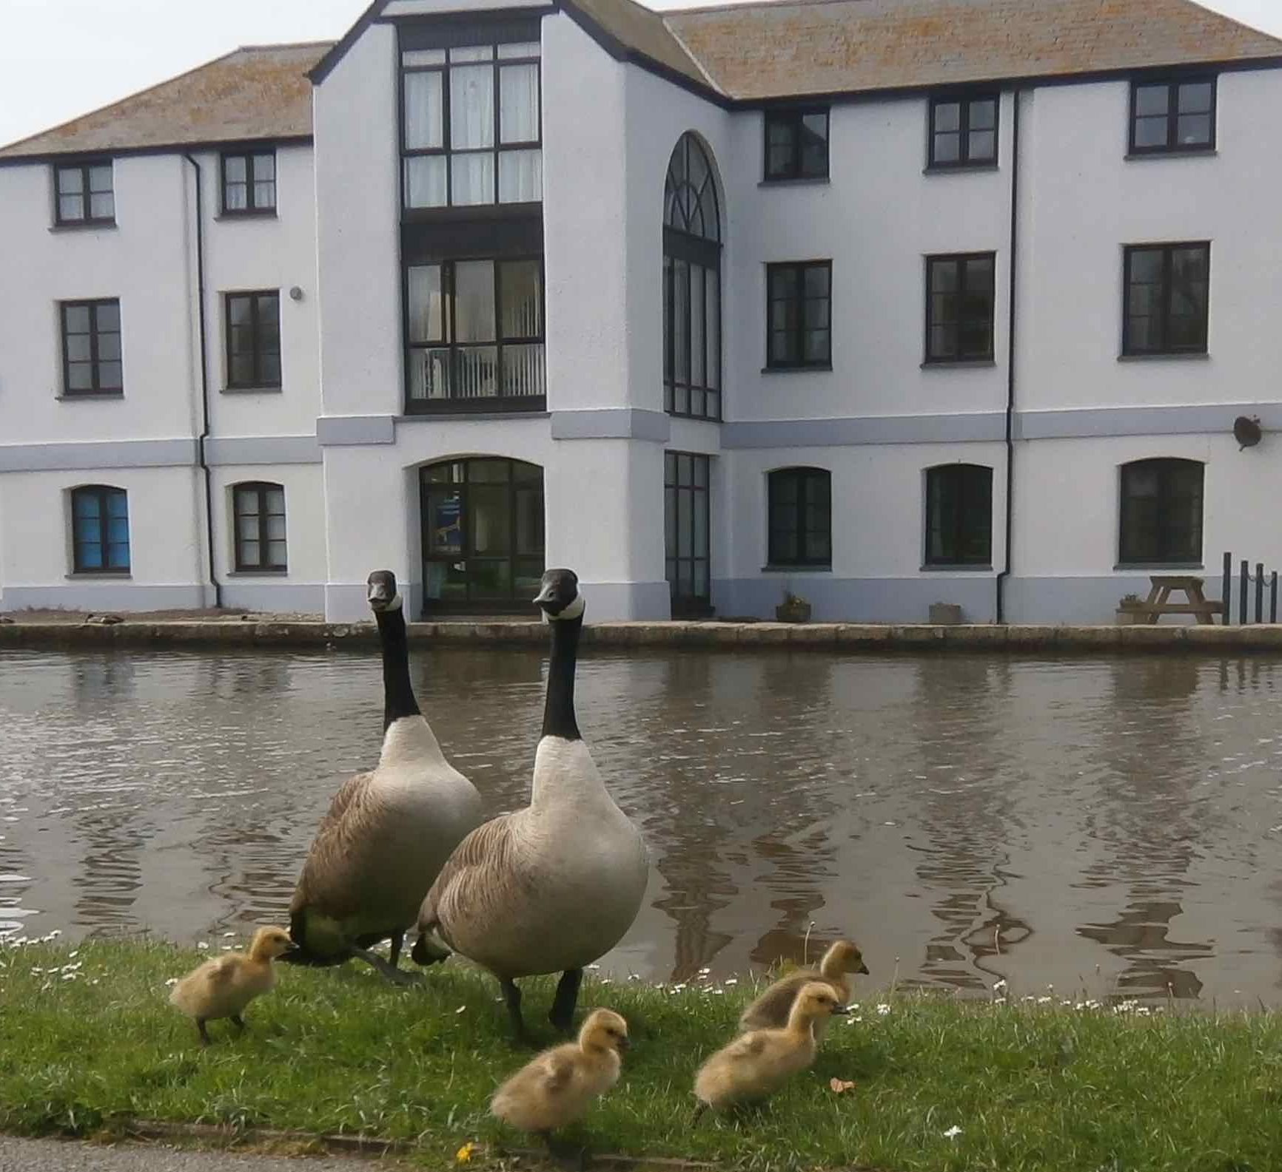

Beam Me Up…
TO SAY THAT I was startled would be to express my feelings at the time very mildly indeed. That horrible word ‘gobsmacked’ springs far too readily to the lips––even mine––these days. This was supposed to be a controlled scientific experiment, not an excursion into magic circle tricks. What had startled me was the way Damien appeared on stage ‘in front of my very eyes’ in a puff of smoke, to a recorded roll of drums.
“Julius, you said you wanted everyone to think outside the box on this, so that’s what my team and I have done.” This came from Damien Heffner, our tame Yank, over here studying for his PhD.
“OK, Damien, let’s see what you have to show for your efforts, but I sincerely hope you aren’t treating this exercise as a spoof. I take it your whole team are behind you in this?” I looked around the faces of those brilliant young scientists, all of whom had signed up to my project in their spare time. Clearly, there was no dissent. Every pair of shining eyes I looked into was up for whatever it was that was coming––and there were a couple of pairs of sloe-eyed beauties that any man worth his salt could drown in.
“Who’s going to start?”
It was Petronella––Pet for short––who stepped up to the illuminated podium, laser pointer in hand. These guys had learned their presentational skills in a school of hard knocks. No hint of PC here. The girl was a beauty and the length of her skirt made sure eyes in the male-dominated audience would never stray from her.
“The subject of Professor Czar’s challenge was for our team to demonstrate that teleportation is in fact feasible and not just a sci-fi figment of tortured imagination; that, in fact, the immortal words of James T Kirk “Beam me up, Scottie!” will soon be a reality as common as “Your place or mine”.
I would have liked to think that Pet was looking into my eyes when she said that. Dream on JC. But I digress.
Pet continued: “What you have just seen––Damien’s arrival on stage, that is––was indeed a spoof, but it is one that won’t be repeated. The demonstration you are about to witness is very real. Some of you may find it disturbing, even a bit weird. Nevertheless, we are going to show you what can be done now, and, believe me you will need to fasten your seat belts, metaphorically speaking, because it is amazing.
“Before we go ahead with the demonstration, let me explain to those of you who have not studied the subject in any great depth. I’m not going to go into a lot of boring detail, so don’t get up and leave yet…” an appreciative chuckle spread around the audience and she continued unflustered. “Various experiments on teleportation have been carried out, and, while some success has been achieved––transferring photons of light instantaneously from one side of a river to another as long ago as 2004, in one instance; passing information from one ‘entangled’ particle to another as recently as last year, in another––the general assumption, even among very open-minded physicists, is that it will be impossible––maybe even for hundreds of years to come––to achieve the level of coherence between objects necessary for teleportation as we conceive of it today. If you don’t know what ‘entangled’ means, see Professor Czar afterwards.
“I am sure none of you here would think it much of a success if the only way a live teleportee could move from place to place would be to create a copy of herself at her destination, leaving her real persona behind, perhaps in some kind of stasis––or maybe even dead. What would have happened to body A while she was in body B––or even C? And could body B or C be considered real? Or would they be thought of as fakes? No. Not acceptable. Not only must consciousness be transferred to the destination, but the real body––as we see in TV movies.
“Now, we can’t pretend to do that yet, but we will demonstrate one way in which scientists may get there sooner than anyone has imagined possible to-date.
“A very recent breakthrough in 3-D representation has allowed scientists in that field to create free-standing holograms that can move around and actually articulate in a free space, albeit they can’t move out of the laboratory as yet. Star Trek fans will now be thinking in terms of ‘holodecks’, I’ve no doubt, but they are a long way from achieving that sort of interaction, I can assure you. We are very lucky to have on our team two members who have had close connections with this work during their first degree courses, and who have been able to take advantage of the expertise they gained to allow us to set up this experiment.
“Hidden by the curtain behind me is an electromagnetically screened cage that replicates the primitive ‘holodeck’, if you like. Damien, our teamleader, has been brave enough to volunteer to be the subject of our demonstration. Don’t worry! What you are about to witness has been tried out before in laboratory conditions and by gradual progression to reach the stage you are about to see. I assure you that no live animals––etcetera have been harmed in the course of these experiments.”
Pet aimed her pointer at a graphic target on the screen behind her and screen and curtain swished back to reveal a mock-up ‘holodeck’ complete with its grid of squares on the walls, floor and ceiling, and fronted by what appeared to be a glass screen. Another click on the console, and a life-sized hologram of Damien appeared in the ‘holodeck’, gyrating slowly on a pedestal, but so far otherwise immobile.
At this point Damien in person walked confidently onto the stage and sat down on a chair of the dentist’s variety, ‘borrowed’ from the college clinic. Two further white-coated members of the team now appeared and began attaching various sensors to Damien’s head. He looked calm enough but I could see that he was nervous from the glistening sheen of sweat reflecting the stage lights.
“Now, let’s begin…” another melodramatic roll of drums, and the lecture-theatre lights dimmed for a moment as a powerful generator started backstage, settling down to a deep-throated hum. “Are you ready, Damien?” He raised one hand in acknowledgement.
“Then, people, I give you for the first time in front of a live audience the world’s first public demonstration of a form of teleportation. Watch closely, because what you are about to see can only last for a minute or two.”
All eyes now focussed on the now prone figure of Damien. A large camera-like object had been swung into place over his head, making me suspect for a moment that we were about to see some phoney computer graphics. Another click on the console and the lights on Damien dimmed and those in the ‘cage’ began to glow.
What happened then was truly amazing––trick or no trick. The semi-transparent hologram suddenly mutated into a very solid-looking replica of Damien and stepped down from its pedestal. All of us watching gasped audibly at the sight, and one woman even screamed. I can only liken it to a horror film reaction.
The figure on stage grinned mischievously and walked over to a telephone on a side table that I hadn’t previously noticed. He picked up the handset and pressed a key. My cellphone buzzed in vibration mode in my breast pocket. Somewhat hesitantly, I answered it.
“Hi, Prof. Would you care to step up and see if I am real? Oh, perhaps you would check that the real me is still alive on the couch over there first. If I’m not, there could be a problem.” He grinned evilly.
I stood up and walked rather apprehensively over to the prone figure on the ‘chair’. Damien One was as still as a corpse. I felt for a pulse at the carotid artery. For a second or so I couldn’t find one, but then––much to my relief––I felt a faint stirring beneath my fingers. I moved apprehensively towards the cage.
“Julius, at this stage we can’t invite you to touch me. I’m sure you’ll understand that, but you can approach and examine the cage. Verify for yourself that what you are seeing is indeed real and not just smoke and mirrors. I can only give you a few more seconds––the power drain is enorm…. Oh, my God! What’s happening?”
The hologram in front of me suddenly froze, flashed back onto its pedestal and shrank to nothing. The lights in the theatre went out with an ominous bang from backstage. Something had gone horribly wrong. The emergency lighting flickered on. The white coats crouched over the still form of Damien. Someone was whimpering with fear…

A Sleepless Night

A seasonal squall lashes against the window pane.
I toss and turn restlessly, seeking sleep in vain.
Nightmares stampede – meaningless, unbidden,
Banishing rest while rowelled spurs are driven.
I creep from darkened bedroom, too awake to stay,
Descend the stairs, nightlights guide me on my way.
A dip in “London’s Strange Tales” will fill the bill,
Undemanding stories to pick and choose at will.
Odd people, odd places, long forgotten customs
Fill its pages with fun, facts, and long departed nostrums.
Invention, squalor, greed, outrageous charlatans
Rub shoulders with actors, fools and courtesans.
The book has worked its magic – I’ll sleep again.
Back to bed, I close my eyes and snuggle down – in vain.
**********
It’s getting cold. The heating’s low at night to save;
The eiderdown should bring the warmth I crave.
The sheets have cooled, warmth has quit my cosy bed.
I shiver – the duvet’s downy warmth has fled.
The belted constellation bestrides velvet eastern sky,
Jupiter’s bright eye glowers on Gemini close by.
Winter’s here – ancient wisemen knew these things.
Equinox and solstice mark midway, not false beginnings.
Autumn ends ’twixt harvest time and Feast of Stephen,
Calendrists prefer whole months to keep things even.
Shall we have snow this winter, roses in bloom again?
Will jetstream rise or fall? Moon is on the wane.

The seasons march ever on; golden leaves tumble fast.
Bonfire night – echoes of treason – England’s troubled past.
Guy Fawkes Night – have children heard of him?
Carol with the weather forecast from Nottingham,
In period costume, a blue cloak with red lining.
She looks good, and bids us “Guid Morrning.”
We wait and watch. We build our stocks in case – of what?
Hedgerow bounty heralds cold – global warming? Rot!
Bean, 5th November 2013

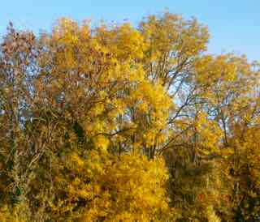

The Lady in Red
RIME IS SOMETHING we don’t see much these days in the south of England. The last time I saw any was while driving over the Hogsback, on my way to a funeral. The filigree lace patterns in the trees were a delight to behold, but I was glad to be behind the wheel of a well-heated, modern car and not out there, shivering my backside off.
“I thought global warming was supposed to have put an end to glorious weather like this,” I said to Liz, who was staring out of the car window, lost in a reverie of her own.
Diligently sticking to sixty for once, I still jumped when I heard a police car blaring out its warning not too far behind us. A quick glance in the mirror revealed not one but at least a half dozen vehicles, their headlights blazing and blue lamps flashing. Three police cars, a fire engine and fire management estate car shot past, quickly followed by a couple of ambulances.
“Must be a big one,” I thought, wondering whether ‘one’ was a bomb––you never know these days. “Probably late for their Christmas Party,” I remarked to Liz, trying to take the sting out of the situation and hoping we weren’t going to be held up.
I kicked myself mentally for even thinking that––how selfish can you get?
We had been making good time and were on schedule to get to the crematorium with about a quarter of an hour to spare. Liz was already more than a bit touchy – the funeral was for her favourite uncle. I wasn’t flavour of the month anyway for leaving an hour later than she planned. I had no intention of mingling with a load of rellies, I didn’t know and didn’t want to know.
The only good thing I can say is that the crash happened on the wide bit with three lanes and a hard shoulder. We were still reduced to a crawl, everyone slowing to gawp at the carnage. We came abreast of the scene as the police were busy coning off the area to safeguard the emergency services and in preparation for their usual totally unnecessary fingertip examination of the site. A few officers were already eyes down like a bunch of crows, looking at the road surface for skid marks––or shell cases.
It was a three-car pile-up. The first had obviously run into the back of a truck, parked on the hard shoulder some way ahead. The second and third victims had obviously been tail-gating the first car and hadn’t been able to avoid the consequences. The fire tender was dealing with a blaze – the second vehicle had obviously hit the one in front hard enough to rupture its petrol tank. The result was horrific.
There was at least one corpse stretched out under a hospital blanket by the roadside. A couple of walking-wounded were being helped into the second ambulance, while the first was just pulling out into the traffic ahead of us with the seriously injured. Liz had averted her eyes and was now beginning to sob quietly. This was definitely not going to be a good day. I sought for words of comfort, but what came out didn’t exactly fit the bill or cover me with any glory.
“Just as well we didn’t leave any earlier. That might have been us.”
“How can you be so heartless?”
“Why, what did I say?”
“Didn’t you see what that second car was? It was just like Sheila’s––the one she bought after the divorce.”
I didn’t like cousin Sheila much––the way she had screwed her ex-husband, Jim, for every penny he had and took the kids as well as the house was pretty shabby, even if it is par for the course these days.
“There are thousands of cars like that on the road. She wouldn’t be coming this way anyway.” I really hadn’t a clue which way she’d be coming. Best try and take her mind off things. “Knowing Sheila, she’d come out of a crash like that without a scratch anyway––then she’d make another fortune, suing some poor bastard for whiplash.”
“Pig!” was all the answer I got, plus a distinctly cold shoulder.
We scraped into the car park behind the funeral cortege and managed to join the rest of the mourners as they were filing into the chapel. Fred wouldn’t have liked this. He had no special religious beliefs and told me he wanted to be left out in a black bag for the dustbin men to take away with the usual collection. I’d told him that they wouldn’t accept him for recycling, which made him chuckle.
We found seats in the back row––that was going to put me even further into the deep and smelly. Liz was always the favourite niece and felt that her place was alongside her bereaved aunt. I certainly wasn’t going to hear the last of this.
But we weren’t the last people to arrive – some consolation. As the coffin was brought in, I caught a glimpse of three other figures; a woman dressed from head to foot in red – a bit bright, even if Aunt Jennifer had specified no black – with a couple of nondescript children in tow. I hadn’t seen any other cars pull in behind ours, but then we had had to use a pretty nifty bit of footwork to get into the chapel before the coffin.
Service and obligatory two minutes navel-gazing over, we turned to leave. The little group were still standing at the back of the chapel. They had made no attempt to slip into the pew next to us. She seemed familiar; the children were just like any others to me. She just stood there, staring forwards and taking no notice of any of the departing congregation. As I turned to file out, I saw her take the children by the hand and begin to move towards the ‘altar’ rail. I was rooted to the spot. I wanted to intercept them, but couldn’t move a muscle. I felt Liz tugging my arm: “Come on, I don’t want to hang around in here. They’re trying to get us out so that the next lot can come in. What are you staring at?”
It WAS Sheila and her two brats. They began to move up the aisle and through everyone else––yes, through––stopping when they reached Jennifer, who was busy thanking the chaplain and Fred’s colleague who had delivered a splendidly OTT eulogy. Jennie shuddered as if suddenly feeling the cold.
“Didn’t you see her?” I hissed as I made a hasty exit.
“See who? Come on, let’s go and look at the flowers while we wait.”
A police car turned into the drive. A young policewoman got out––this was surreal. She approached and addressed me directly:
“Is this the funeral of a Mr Richard Faraday?” I nodded mutely, listening to a death knell I knew no one else could hear.
“I’m afraid I’ve got some bad news, sir. Mrs Sheila…

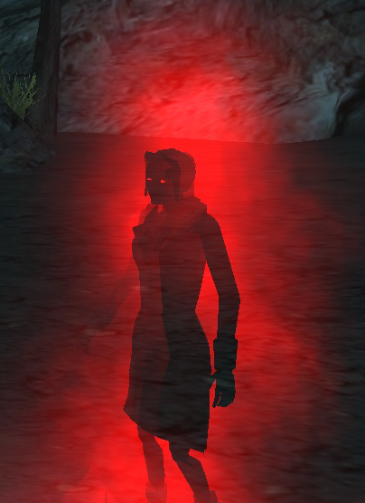

Epilogue
Let no one tell you not to grieve.
Your tears will fall, you need to cry.
It’s human nature to believe
Your dearest love can never die.
So mourn awhile, avoid frivolity.
Anger pursues the new bereft,
Denies that death’s life’s destiny;
It rails against Nature’s cruel theft.
Make time for friends to hold you tight;
For family to share your loss.
Banish unwelcome thoughts of night
That make it hard to bear your cross.
Soon silent pity starts to pall.
Fond memories bring smiles, not tears.
Secrets once shared you will recall
With warmth that calms unwanted fears.

One day you’ll wake, sweet dreams enjoyed.
Again you’ll welcome gentle mirth.
Again ambition’s hopes are bouyed,
Then love has proved its depth, its worth.
Bean, 25th September, 2013

The Broken Leg or

Be Careful What You Wish For
I DON’T KNOW the origin of the oft-quoted theatreland epigram: “Break a Leg”. I suppose it’s a bit of sick humour, common in any established group of colleagues, where people wish each other all sorts of dire outcomes, meaning precisely the opposite. Nowadays, no one who enjoys the backslapping camaraderie of the workplace wants to come across as cloyingly trite anyway. However, it is undoubtedly a throwback to our superstitious past. It used to be considered unwise to call for luck unnecessarily – the gods were well known to be mischievous.
Don’t want to go to some ghastly reunion? “Sorry, no-can-do. I’ve broken my leg.” Simple and convenient, and, let’s face it, pretty harmless if you’re unlikely to be discovered. You’re not likely to meet the organiser or any of those ‘old pals’ you haven’t seen in years, and a broken leg can take ages to heal properly. But be careful. It’s not worth claiming to have a simple fracture that any decent fracture clinic can deal with in weeks these days.
What’s going to happen when scientists in the medical world develop a procedure to ‘grow’ a new bone in situ that only takes a week or two of rest and recuperation? If they can grow a new windpipe on a child in a couple of weeks without being accused of reckless experimentation, that can’t be far away. Another door closes on the world of comfortable little white lies.
I suppose it isn’t really ‘the oldest excuse in the world’. That’s got to be: “I’ve got a headache,” but let’s not go there. Let’s stick to what passes for a good excuse in the polite world: (no sex, no politics).
“Sorry I’m late. I missed the bus (the train, my lift).” Not effective and likely to get a sharp response such as: “Try getting up a bit earlier!” or “Yes, I’m not surprised. I heard about your binge on Saturday night.”
Of course, those of us who have never had the misfortune to break a leg mustn’t laugh at those who have, even when the circumstances prompt an unbidden belly laugh––the old banana-skin syndrome. Apart from being extremely painful, the results can be tragic.
**********
Jimmy hated football at school. He envied his best friend Pete, who spent weeks on his bed at home and then more weeks hobbling around on crutches, getting sympathy from everyone, with a huge plaster that everyone wanted to autograph. Pete missed a whole season, when it seemed to pour with rain every time the sports master organised a match, while he and the other boys teams got soaked and covered in mud––lucky devil!
Why couldn’t it have been him who fell off the old army obstacle course, hidden in the woods, where they used to say that the paratroopers trained during the war? Why did he have to get a thick ear from his dad instead of congratulations for rescuing Pete by going for help and leading the ambulance men to their secret playground? Why?
Jimmy began to look at Pete through different eyes after that. Envy is a sneaky thing. It insinuates itself into all sorts of nasty places, and is no stranger to broken friendships––Jimmy was too young to know anything about broken marriages. But he did have a favourite girlfriend, the pretty and vivacious Sonja, who all the boys tried to corner on the rare occasions when the girls agreed to play kiss-chase. They shared a desk in the classroom and she always seemed to like holding his hand, when they were paired off to walk in a crocodile on a school visit… unlike most of the girls, who would snatch their hands away and make nasty comments like: “Yuk! You don’t know where it’s been!”
Now envy turned to jealousy––even in one so young––when Sonja started to make sheeps’ eyes at Pete and take every opportunity to sit with him and share things with him. It got even worse when she started helping him scratch down inside the plaster with her knitting needles.
Pete seemed to be enjoying his status as some sort of hero. There always seemed to be something to stop him having the plaster off and getting back to the old mischief that they used to get up to. He had always been the one to initiate the practical jokes and the adventures in the hills and woods where they had had such fun in the previous summer holidays––carefree, sun-filled days, when they made their own fun, far away from the interference of parents and adults in general.
Jimmy’s jealously soon descended into petty spitefulness and Sonja never forgave him for that. She, of course, had her own way of dealing with it. She made sure that all the other girls in their class would have nothing to do with him after that. It didn’t matter much at that age when girls were usually objects of scorn anyway, but things didn’t get much better when he wanted to start dating years later at big school. And they say elephants never forget!
Winter dragged on with extra classes for the eleven-plus pupils––Jimmy was one, of course, being a bit of a swot. Pete would never have made it to Grammar School. In classroom terms he was as thick as two short planks – a term Jimmy had heard his dad use to describe his best friend. What Pete lacked in brainpower he more than made up for with his ability to make people laugh and his practical skills, like making bows and arrows and building dens in all the forbidden places they thought their parents knew nothing about.
Come the summer term, Pete was still on crutches and there appeared to be no end in sight to his constant visits to the clinic and the odd stay in hospital. Jimmy stopped visiting him when he went in after a while. They didn’t have much to talk about anyway. He still couldn’t get over the way Pete had pinched his girlfriend. That was an open sore between them. But he was secretly worried about his old chum. He knew something was wrong, when he saw Pete’s mum in tears, coming out of the headmistress’s office one day. It was when Pete had been in hospital for longer than usual and he hadn’t been to see him––or his mum. He liked her––before it all happened. She was pretty and used to make the best brandy snaps for birthday parties.
Then it all came out. It was their form mistress who broke the news in class one morning just after the register had been called. She was usually a po-faced old biddy, was Miss, a dried up old spinster, whose face would crack if she ever smiled. That day she seemed to be having difficulty in keeping her voice under control, and her eyes were all red, as if she had been crying. She probably had, because what she said to the class then made everyone cry––even Jimmy; even though he had wished some pretty awful things would happen to Pete after Sonja ditched him.
The broken leg had not been a simple fracture at all. It hadn’t healed properly and somehow or other Pete had developed a bone marrow disease that couldn’t be cured. He had died in his sleep in hospital the night before, with his family around his bed.
Jimmy wasn’t invited to the funeral, although he did stand in the street on the wet Saturday afternoon and watch the hearse drive away from outside Pete’s house, followed by three long, black cars carrying his father and mother and all the relatives. His mum had stood there with him, tears streaming down her face as he clung to her hand. She clutched him to her and gave him a big squeeze as the cortège drove past.
All Jimmy could think of was the big scaffolding in the woods where he and Pete had been playing when he fell and broke his leg. Now he had a terrible burden to bear that he knew would never leave him. He could hear his own sing-song jeers ringing in his ears. “Scaredy Cat, Scaredy Cat. I bet that you won’t dare do that.” And then he did. And then he fell. And the worst part was that Jimmy hadn’t swung along that high pole. None of his friends dared to even climb up that high, let alone swing along it. But Pete wasn’t just any one of their little gang of friends. He was Jimmy. He was his Best Friend. He was the best, the boldest. He was fearless. He would dare anything, and they all knew he would. And then he did and now he would never do any of those daredevil things again. And now Jimmy had a burden of guilt that would stay with him all his days––even after he met Sonja again at uni and they fell in love. He couldn’t commit to her, the girl of his dreams––now his nightmares.
He died in hospital many years later, a broken, reclusive old bachelor, and no one ever knew why he was so bitter––not even Sonja, not even his mum. He had wrapped himself in his guilt and the fear of a broken leg.

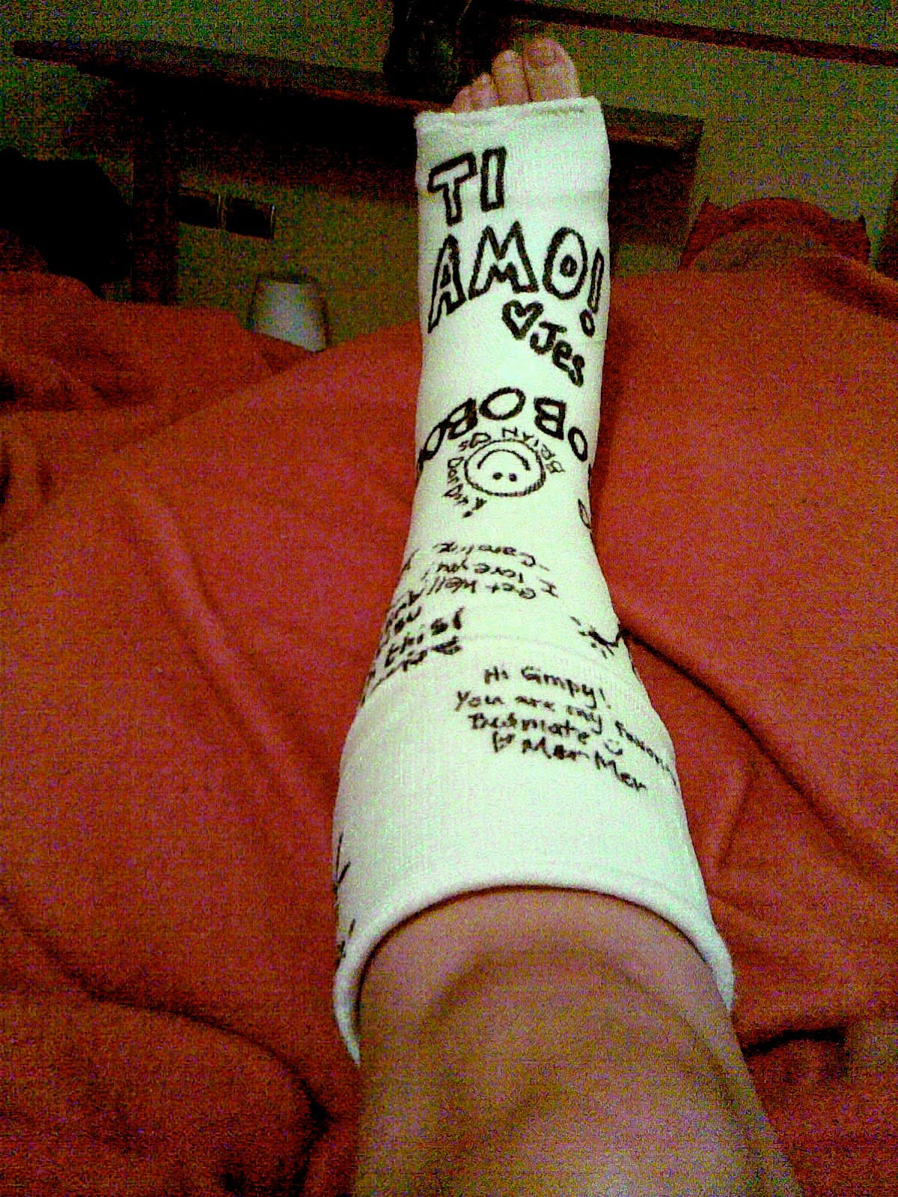

Drinkies Time!

Gee an’ tees is for sippin’ not guzzlin,
So the wife says, an’ she ought to know.
But somehow I find it real puzzlin’
How ’ers last till mine’s gone… then, cheer-oh!
Whisky Mac! Now there’s a fine taster!
Warms the cockles, as they say down in Kent.
Now, good whisky’s a real penny waster
But good ginger is money well spent.
Brandy sour, there’s a cocktail to master,
One to conjure the tropical sun.
A tip – take lemon and a rough sea salt caster,
Rim your glass before mixing this one.
Singapore Slings are a wonder
From Raffles they come, so they say.
I’ve forgotten the secret - a blunder
I’ll rue till I’ve found the right way.
Pink gins are a naval man’s tipple…
He’ll drink ‘em from sundown till dawn.
On his composure they’ll scarce make a ripple …
Till you tell him the pinkers all gorn.
Now beer for the lads may be healthy,
But the ladies don’t often imbibe.
Perhaps a lager for those that aren’t wealthy,
Port and lemon for the commoner tribe.

Bean, c1999

The Certainty of Uncertainty
“ONE DAY YOU will die. That is absolute certain. Uncertain is what will happen to you––your concept of ‘you’––after that. If you could answer that question without resort to religious dogma––the one question that defines humanity and places humankind above the animals––you would, indeed, be worthy of a place in paradise.”
I was sitting cross-legged––fidgeting might be a better word––uncomfortably on the stone-flagged floor of the abbot’s cell, my back rigid as a poker, trying not to slouch in front of the wise man, whose teaching many had sought, but few had understood, although some pretended to do so. Could I be any different? What kind of arrogance, what kind of misplaced self-esteem had driven me to embark on this pilgrimage in the first place? His droning voice broke through my personal firewall of discomfort.
“Sadly––or perhaps not––no one has been able to fathom out how to prove their theories without moral trickery of some kind. A few ‘prophets’ have convinced themselves and their followers that they know all the answers. Such charismatics have used every trick in the book to ensure that their ideas live on. Their disciples have in nearly every case ‘enhanced’ their ideas and convinced powerful leaders that by adopting them as a code of civil demeanour they will be able the more easily to dominate their subject people and go on to rule first tribes, then nations and, finally, great empires. That may not have been the intention of the originator of such codes, but it is without fail the end result.
“Look at the man so many millions call “Our Lord”––yes, Jesus himself. Now, he was a far from orthodox Jew. They say he struggled throughout his short lifetime against bigotry and prejudice. I don’t think his aim was ever to find the answer to what happens in the hereafter. He was pretty sure he knew that from every religious tenet that he had imbibed with his mother’s milk. No, he taught a way of life based on a code of kindness and forgiveness that was quite alien to the Jews amongst whom he’d been raised. He certainly wanted to export his teachings to the world as he knew it––the Roman Empire in his day––but there is no evidence that he had any desire to impose them by force.
“Some say that Jesus was influenced by Buddhist teaching and possibly even the Hindu philosophy of life. If indeed he was a high-ranking priest within the Essene brotherhood, Jesus would have undergone six or seven long years of indoctrination in all manner of religious ideas. The Essenes were extremely erudite men, whose beliefs were not confined to orthodox Judaism. They were known to have close connections with religious bodies in Egypt, the so-called Therapeuts, who dabbled in pagan knowledge of the ancient religion of Isis. There is no reason to believe that they confined their intercourse to the religious beliefs that prevailed on the shores of the Mediterranean Sea and its immediate hinterland. The Jews at that time were sitting at the very focus of many trade routes from the mysterious East. They would have been familiar with concepts of self-denial and reincarnation that were common in the little known lands beyond Arabia. The Greeks and Romans may not have placed much value on what lay beyond the desert sands to their east. Even Alexander the Great…”
**********
My mind began to wander––back to the dusty heat of Helmand. I could almost smell the stench of rotting Taliban stinging in my nostrils, two days after an airstrike had obliterated the mini fortress they had constructed with its maze of tunnels and escape routes, spreading their shredded remains like animal droppings over the rock-strewn hillside. They had dominated the mud-walled peasant village in the poppy fields below with the viciousness that only religious fanatics can display. Had they all gone to paradise and been rewarded with however many virgins they believed was their just reward?
Sitting smoking at ease beside my Afghan interpreter on the low bank of a ruined cantonement, I had wondered how he reconciled what he was doing with his own religious beliefs. I knew that he had no time for the Taliban or men of their ilk, but did that mean that he had any more time for our western way of life. This was a man, brought up to believe in male superiority, to pray to his God five times a day, to accept brutal punishments, long abandoned in the modern world he had only ever seen on television––and then only illegally. Did he secretly believe in the final solution of a re-born Caliphate? I never did pluck up the courage to ask him.
**********
“Tell me …“ The Abbot’s sharp query broke through my hazy daydreaming. Even my dull wits recognised the warning that his patience was wearing thin. “Why have you come here? I cannot believe that you have any real desire to debate philosophy with me in this peaceful retreat. Are you troubled? You are much travelled. You have seen things that men of peace should not see. Do you seek answers to questions that recent experiences have raised? Or do you, perhaps, think that you will find something here that will give you ammunition – and I use the word advisedly knowing your background – to go out and storm the bastions of organised religion and reinforce atheistic ideas that have taken root in your mind as a result of the senseless violence you have witnessed?”
His directness struck me almost forcibly. That this enigmatic, wizened ascetic with the reedy, warbling voice and deep-set hooded eyes, had seen through me, had unmasked my sham alias, came as something of a shock. Why, indeed, was I here in this mountainside monastery, far from the luxuries that I had dreamed of, almost obsessively, while I was swanning around in the hills of Afghanistan with the army patrols, trying to flush out men who were born to the life of guerrilla warfare, men to whom barbaric cruelty was a worthy code of behaviour in itself, if it meant that their souls would ascend to Paradise when the bomb or bullet finally caught up with them?
“Holiness, you ask the question that I have been asking myself ever since I arrived here. If the truth be told, I’m lost. I don’t know what I believe or what I want to believe anymore. I suppose I came to you in the hope that I might be able to retrieve some foundation on which I could build a future. I am not a suicide case – that’s the coward’s way out… unless, of course you’re a bomber, in which case the coward is the bigoted villain who brain-washes and sends you to your destiny with promises of rewards in an afterlife.”
“Are you so certain that suicide bombers don’t go to their deaths voluntarily?”
“There are many reasons behind what they do. Some go willingly on their murder missions, if misguidedly. Many are driven. I have witnessed great sacrifice by desperately poor people with nothing to give. I have seen acts of great heroism by people of whom heroism is not expected––ordinary people––particularly women––who refuse to be bullied by bigoted fanatics. I have never been able to reconcile either self-sacrifice or heroism with the horrors of suicide bombing. Why, why do they do such things in the name of whatever God they believe? If God is Great then how can religious leaders sanction such deeds?”
“You must learn to distinguish between power-seekers and men of religion. Renegade mullahs who preach violence want to perpetuate their power through their distorted interpretation of a code of behaviour rooted in the seventh century. Hindu fundamentalist saddhus want to impose their ideas of sanctity on their followers to stop progress towards real democracy and western materialism, which they see as fast corrupting their people. Such people are not religious. Indeed, they are the very opposite. History gives us many examples––the Inquisition; high priests of the Inca and Aztec people; even Buddhism has had its renegades.
“No, they are despots with not a shred of compassion. Their one motive is power. They only know one way to achieve it; that is to crush the spirit of their subject people.
“Go and use your journalistic skills to persuade honest politicians to lay the foundations of a simple code of ethics related to the basic tenets of all the major religions––one that can satisfy theists and atheists alike. Leave it to those of us who have retreated from the corruption of modern living to pursue our simple taste for philosophical debate. You never know––one day we may by some miracle find the answers that elude even the brains of the finest scientists and lay to rest the ghost of dreaded Uncertainty.”

Eternal Love

When I die,
Suffer me to go quietly,
A decent man, a private man.
Some believe…
I am not one of these…
This is the end, there is no more.
So let me
Slip peacefully away
Without fuss, without tears.
Let me be
Like the storm that passes
Unheeded, without memorial.
I should hate
To be cast as a tragedy
With wailing mourners in my wake.
Our twin souls
Are like one glistening sheet
Of hammered gold, expanding with each blow,

Its surface
Branded with the immortal truth
Of our oneness, our undying love.
We can part
And parting Still be one,
Without yearning for each other’s touch.
Yet, if two
We must at last be proved,
Then do not forget the ties that bound us.
I shall be
Still the anchor of your life,
The guiding compass of your being,
As you have
Always been mine, my lodestar,
The constant companion ever at my side,
The compass
That brings me ever home
Back to the hearth, that cradle of our dreams
Critical readers might think this is a deliberate attempt to plagiarise the work of a poet far greater than I will ever be. If so you may like to look at the challenge I was faced with at the time I sat down to write. I was ignorantly unaware of the words of John Donne's famous work.
The effort above arose out of a challenge on MyT to interpret the following:

The prose from an undisclosed poem:

the challenge? To put it back into a poem:
You know, when decent people die, they just softly ask their spirit to leave. At the same time, you've got a fair few of their despairing friends saying, this is definitely it, death, the end, and others are saying, well, no, hang on, not just yet. Well, this is how I would like us to be parted; silently, without any crying or hysteria. Because, the thing is, it would be a complete betrayal of the love we have to go around shouting about it to all and sundry. I mean, let's face it, earthquakes can cause massive devastation and terror, and everyone has an opinion on them, but meteorological disturbances which are much grander and of a bigger scale, go unnoticed and are not harmful. Take a look around the world; there are some really ordinary people who are obsessed with their lover's physical appearance; they just couldn't put up with being apart for one minute, because it would mean being away from the thing they are in love with. But we're different. Our love is so pure and untainted that we hardly know how to define it; the bond between our minds is so strong that it wouldn't much hurt us to be deprived of seeing and touching each other. I think that our spirits are really just one spirit, so even though I am forced to leave, they will not be torn apart, but will just spread out, like gold when it is beaten and melted into a thin, sheer layer.
But then again, if we are separate entities, then I would like to think of us as the legs of a compass: your spirit is the leg in the middle, which, to all appearances, remains still, but nonetheless moves when the other leg does. It's stuck, but it tilts and yearns towards the other when it has gone away, and becomes stiff and upright once again when the other leg returns. This is just how you are for me, when I am forced to dash away; your steadfast resolution makes my circle perfect and enables me to end exactly where I started.
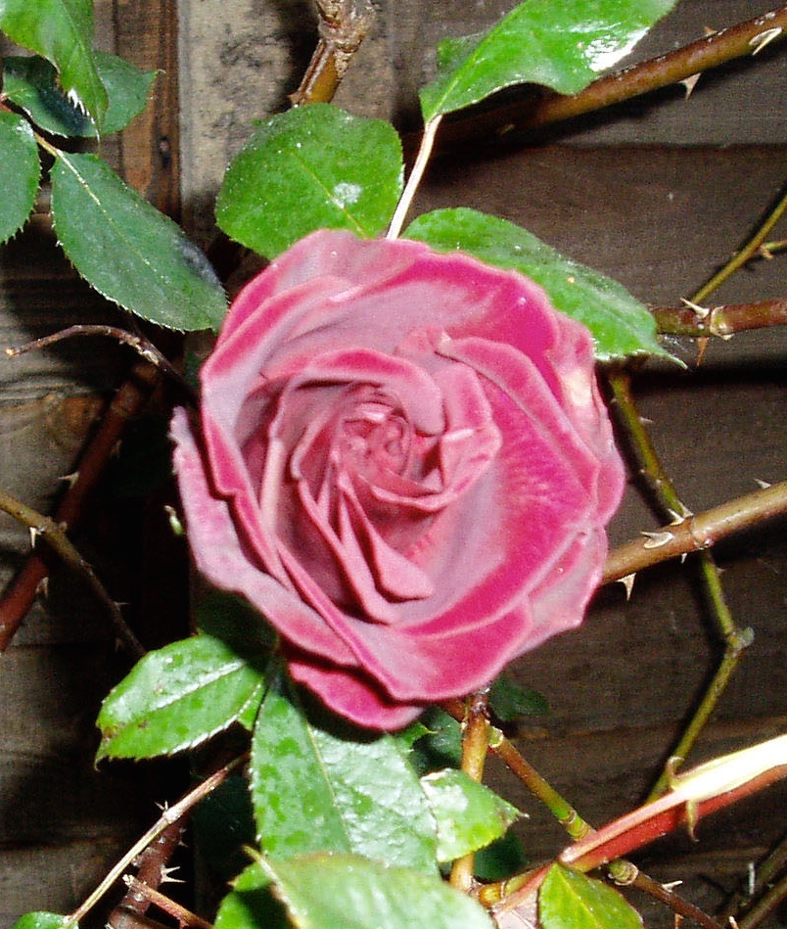

Night Sky at Jaisalmer
THE BLAZING HEAT of the day had subsided at last, drifting away as if reluctant to allow the cool night breeze to bless the intruders in its desert fastness with its scented balm. Wonderment flushed through my barren soul as I gazed up at the black velvet, jewel-studded sky––such a feast for the jaded eyes of a city-dwelling infidel from the West.
I was alone in my charmed reverie, lost in my solitary contemplation of the starry sky above me on this ink-black, moonless night. My companions and our hosts, were still relishing the delights of the rude hospitality of our camp on the edge of this wilderness. The smells of the highly spiced feast we had just shared still hung in the cool air, masking the stench of hot metal and diesel fuel from our vehicles, mingling with the oily staleness of the old, dust-impregnated canvas of our shabby, tented mess. It all seemed so out-of-place and incongruous in these ancient surroundings.
The lamplight, twinkling from the intricate stone-lattice windows of the nearby fortress retreat of ancient robber barons, did not desecrate the night sky in the way the coarse, bright illuminations of Western towns would with their intrusive glare, robbing would-be stargazers of this spectacular display. If anything they enhanced the beauty of the heavens, like a sparkling necklace reflecting dancing firelight on the bosom of a beautifully-gowned woman.
I had suddenly and inexplicably grown irritated by the constant round of shop, mingled with lewd banter and coarse jokes that seemed to be the entire repertoire of my companions––fine fellows all without a thought of culture in their heads. Not for them any contemplation of the unaccustomed beauty of that desert sky––not for them any wistful thoughts of loved-ones far away, of shared moments of the pure communion of spirits, gazing on a summer night in another place and another time at the pallid facsimile of the shimmering vault above us, a feast for tired eyes.
All I wanted at that moment was to steal away into the rolling sandhills, to vanish into the night and lose myself in their imagined untainted purity, to abandon the all too worldly activities in which I was reluctantly involved, to escape all responsibilities…
A richly deep, familiar, accented man’s voice at my side woke me from my self-destructive dream: “Beautiful, isn’t it, my friend? But we cannot escape, however much you and I may yearn to do so.”
It was my turbanned host in all his regimental finery. I felt scruffy standing beside him in my only clean safari suit. He had noticed my stealthy exit from the celebration dinner he had been hosting to mark the success of our enterprise. Now he too momentarily showed his world-weary side. For a fleeting moment he admitted his longing to return to a quieter life, away from the cares of command.
“Come. You and I must not desert our brothers in their moment of triumph. We were not so very different from them––and not so long ago. Perhaps we have outgrown their youthful exuberance but we cannot show them our weariness with their high spirits. We will lose their respect and that would never do. It is a long furrow we plough but it must be a straight one. They need us, your men and mine. They may have different backgrounds but they are all the same under the skin.”

Night Sky at Jaisalmer
The stifling heat of day at last subsides,
Reluctantly unleashing night’s cool breeze,
Sanctioning my incursion in her desert rides,
Scented balm before her chill dews freeze.
Wonder flushes my dry, barren soul,
An infidel worshipping Shakti’s jewelled sky,
Coveting the ebony beauty of this peerless bowl,
Its golden fruits spread before my jaded eye.
Alone in this charmed reverie, lost in dreams,
My spirit wanders the paths of her estates,
Seeking out shapes and intricate schemes,
Yet anchored fast in Mother Earth’s debates.
Embraced in the arms of this ink-black night,
I chance a glimpse of latticed, lamp-lit windows
Piercing the robber barons’ fort. What mystic light
Pricks the darkness with its brazen, flares and glows?
Do flashing almond eyes, defy all thought of duty?
Do they seek their prince amongst those stars,
Diamonds on the breast of velvet-gowned beauty?
Love’s pure gifts. Heaven’s casements brook no bars.
Bean, 25 January, 2011
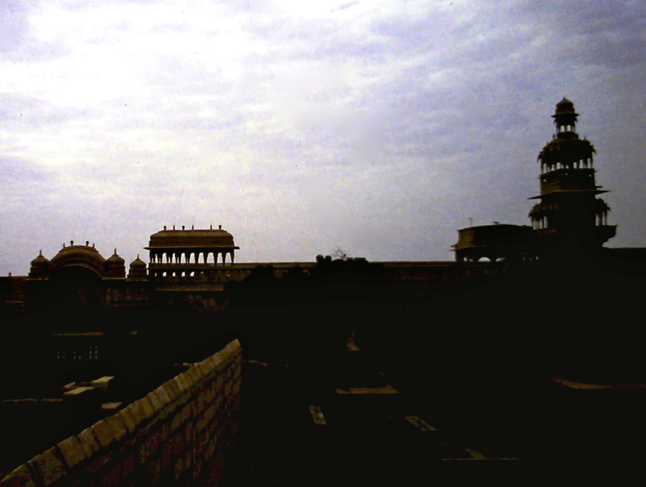

Camouflage
The other day I was walking the dog, thumb-in-bum and mind in neutral, as one of my cruder friends used to say, avoiding the curls of dog pooh inconsiderate dog-walkers hadn’t bothered to push off the path––or better still, pick up and take away for disposal in one of the pooh bins strategically placed at either end of the footpath––when my eye was caught by something on a weed that had somehow managed to avoid being trodden down.
There was something strange about the perfectly common little plant – a lonely sprig of coltsfoot, with its bright and cheerful yellow flowers, basking in the summer sunshine. When I bent down I could see quite clearly exactly what it was that had caught my eye and yet which would have been totally invisible if one of them hadn’t moved. The thing was alive with brilliantly striped, yellow and black caterpillars.
These days it doesn’t take much to set me off musing about almost anything and everything. Retirement gets some people that way. I used to be a bit of a specialist in camouflage in my Army days, having spent a few very enjoyable months on a course to become a photo interpreter, back in the days of high flying aeroplanes and black and white photography, using stereo pairs to reveal what the flat imagery totally concealed. Now, of course, it’s all satellites and colour, infra-red and thermal imaging. It’s very difficult to hide anything deliberately these days; even digging-in won’t help.
Once I’d started musing, of course, the old mind just kept on going off down different tracks and I began to think about all the other things that hide and yet can be brought out into the light of day by clues that are even more subtle than mere movement. Words these days are my particular bugbear. There are times when I find myself searching––here I go again––ah, yes––‘hopelessly’ for a single word that only moments before popped into my mind with a half-formed idea, ready to be written or spoken, depending on what I was engaged in at the time.
Some people are fantastically fluent when it comes to the richness of their vocabulary. Time will tell whether their fluency will last any better than mine. Trick cyclists try to persuade you that you can remember anything if you simply link it to something specific. I suppose that’s true. I could never remember the something specific I was supposed to be linking to! But there are cases where individual words themselves conjure up images of long-forgotten episodes in your lifetime. Or maybe a particular word, totally unconnected with any colour, will flood your mind with a beautiful hue that has nothing to do with what your mind is supposed to be concentrating on. Weird.
That sad word ‘hopelessly’ reminds me of the gorgeous flowing locks of a lovely girl I was desperately in love with as a young man. I’ll never forgot her hair––the colour of desert sands, with all the sharp ever-changing patterns of miniature dune-like waves, and the subtle tints that seemed to change with the sunlight of that long distant summer romance. I can’t recall her face or figure anymore, but the magical hues of her long, wavy hair lived on in my dreams, long after I realised that my passion for the girl was one-way only. Why did ‘hopeless’––that very ordinary and depressing word retain such sensitivity for me? I’ll never know, but there’s no doubt some chain of events lurking hidden somewhere in my sub-conscious.
Music is another medium that hides both actively and passively. Some sensational orchestral pieces – and I use the word 'sensational' advisedly in this context – have been written deliberately to record places and events. There is often little subtlety in film music, composed particularly with subliminal advertising in mind. Conversely, it is often the simplest little ditty––something as simple as a pop tune du jour––that will take you back on a flight of fancy, bringing vibrant sensations that a mere tune perhaps ought not to stimulate. One such always takes me back to the pleasures of a misspent youth in Hong Kong bars and Singapore street restaurants. It’s not just the memories, though; it’s the evocative reality of the actual sensations of taste, sound and smells that never ceases to amaze.
I’ll never forget arriving at Paya Lebar city airport in Singapore at 5 o’clock in the morning one September day many years ago, when I was just twenty-one years old. After all the fuss with DDT sprays and the ineffectual pleas to remain in our seats until the aircraft came to a standstill, the air hostesses finally opened the doors of the even-then-ageing Britannia airliner and let the smells and early morning heat waft over us. As I recall most people gasped at the shock of both, as they tried to adjust to this totally new – and for some no doubt hostile – environment. Me? I just thought: “Home!” Having left the place amidst the smells of a bombed and burning dockside at the age of three and a bit, perhaps that was––surprising, but it was the tangy smell of curing rubber, and the familiar heat that immediately convinced me that this was where I ought to be. It was the smell I hadn’t experienced for nigh on eighteen years, and yet it brought back strong memories of a wholly forgotten life. From that moment on, I had no problem with adjustment to the climate or food, the sights and smells. It was all there, ready-made.
Have you ever thought why it is that there are times when such everyday names as days of the week can conjure up people and events that are long forgotten, even spiriting you away, allowing you to flit moth-like hither and thither around places you haven’t even thought about in years: 'Monday is washing day, is everybody happy?' and I can smell the old zinc bath on top of the gas cooker, boiling up the sheets. I can see my Mum, with her hair done up in a cloth––hard days for her, remembered even now with a lump in my throat.
These are the absorbing, tantalising tricks of the mind that lie hidden in the twists and turns of those little ‘grey cells’ (cue: vision of the TV Poirot mincing down an Edwardian London street), waiting for the random firing of some synaptic trigger event to spark a train of thought and even arouse sensations totally unrelated to the original––what’s the damn word? No, I’ve tried waving my hands around in the hope that movement will trigger a sound, enunciate the word for me. At the moment nothing’s working when I want it to.
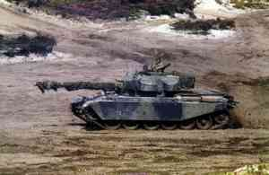

Quotation from Lucretius

(anonymous translation into English from the original Latin)
"What hast thou, O mortal, so much at heart, that thou goest such lengths in sickly sorrows? Why bemoan and bewail death? For say that thy life past and gone has been welcome to thee, and that thy blessings have not all, as if they were poured into a sieve, run through and been lost without avail: why not then take thy departure like a guest filled with life, and without resignation, thou fool, enter upon untroubled rest? But if all that thou hast enjoyed has been squandered and lost, and if life is a grievance, why seek to make an addition ... why not rather make an end of life and travail? For there is nothing which I can contrive or discover for thee to give pleasure: all things are ever the same."
1994, Discovered in a discourse on Epicurean philosophy

Lucretius - On Fear of Death

Come, mortal, why dwell so dolefully
On damned Death's dread destiny?
Why hock thy life for debts to Sorrow,
When Laughter's light is there to borrow?
What if thy life that's past and gone
Has been to thee a welcome boon:
What if thy blessings have not all
Run through Time's sieve to no avail:
Why linger, fool? Like sated guest,
Canst thou not welcome dreamless rest?
This troubled world is no great loss.
Give up the race; flee doom's chaos.
But if thy love of life is waning -
Thou gavest naught so naught art gaining -
If Life to thee is darkly grim,
Stretch not thy stay to humour him.
Surely t'would be better far
To slip out while the door's ajar.
We Gods have naught will pleasure thee,
'Twas ever thus: shall ever be.

Syston, ‘Master of Gaul’ 1994

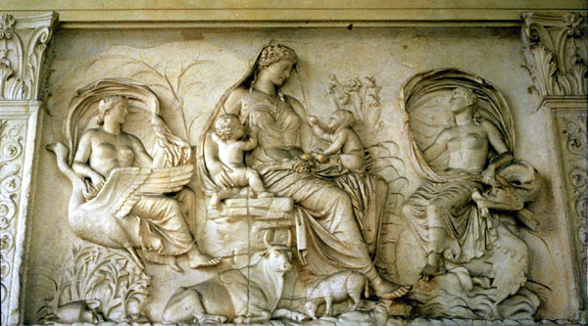
Spectral Dimensions
THE THOUGHT OF a get-together hadn’t really occurred to me – not with him anyway. As far as I was concerned once you’re dead, you stay dead. Ghosts? Oh, purlease …
I’d just put down a brilliant book about the science of the impossible. It covered just about every bit of sci-fi nonsense you can think of and discusses very lucidly whether or not any of it is or ever could be possible. Wonderful stuff––warp drives and anti-matter engines, time travel and telekinesis––you name it, it’s all in there.
I once used a bit of sci-fi time ‘warpery’ in some historical fiction I wrote. I self-published it on the cheap but it didn’t sell. It worked for me at the time and for one or two uncritical friends but clearly not for anyone else. Never got into any commercial outlets – not that that surprises me. However, it was interesting to learn that such a phenomenon might not be so far beyond the laws of physics as I thought. Someone has obviously been very comprehensively re-writing them since I were a lad. But, hey, I guess I am getting a bit out of touch.
It was the hypothesis of the existence of almost infinite numbers of parallel universes that intrigued me––that and the idea of many ‘curled up’ dimensions over and above the four that we commonly recognise in everyday life––three spatial plus time. It stretches the imagination more than somewhat; but then I’m no Stephen Hawking. He has said that there may be up to eleven dimensions to take into account when trying to solve the Theory of Everything. Technologists––as opposed to 'scientists'––used to call them fudge factors but let’s not go there.
It seems inter-stellar travel is so far out of our reach in terms of the energy required that we will have evolved into a totally different species by the time it is feasible, maybe in thousands of years time, so ideas of ever escaping from the solar system must for now remain the stuff of dreams. Sad, isn’t it? But what fabulous dreams they are––dreams that will inspire future generations to achieve things that today we only half believe are possible. Maybe those extra-terrestrials will get to us before we get to them. Perhaps they’re here already––or have already been and gone. I read somewhere that ancient clay tablets found in Sumerian archaeological sites refer to ‘the gods’ as coming from the stars and creating life in their image, before quarrelling over the development of their creation and leaving in high dudgeon.
Clearly the human race has not evolved much––if at all––over the last few thousand years. Let’s face it, Democritus knew about atoms two thousand years ago. It would be surprising if we were not closer to some of the answers; that doesn’t make us any more intelligent. I suspect that if Leonardo were to come through some kind of time portal today, he would adapt to the science and technology around him very quickly and still be a leader in the field of ideas in the arts, sciences and matters philosophical.
Such were the thoughts drifting through my mind a few nights ago as I was thinking of turning in after a pleasant evening spent reading and half watching some unchallenging telly, between snatches of connubial conversation. As was our habit, I had already taken the old dog out for his late evening stroll––the one that gets progressively shorter and shorter––while my wife was getting ready for bed.
As I recall I was sitting in my armchair gazing into the dying embers of the log fire. Old Baggins had settled down on the rug as close to it as he dared and had just started to snore, as old dogs do. I wasn’t surprised to hear a soft footfall pad across the room and didn’t look up––I was happily nursing a crystal bell nightcap of swirling, liquid gold––a well-matured malt, half-drowned with water.
The voice that broke my reverie had a sharp antipodean twang to it and was definitely male. It startled me to say the least. When you’re expecting the dulcet tones of the woman you’ve lived and grown old with and you know there’s no one else in the house, a man’s voice, and a familiar one at that––if long unheard––can come as a bit of a shock.
“’Ow’re yer goin’, mate? I heard a rumour you were getting a bit doddery, so I thought I’d drop by and cheer you up.”
“More likely you smelt the whisky, if I know you.” Our friendship had flourished on banter if not downright insult.
“No thanks, I had to give it up before I moved on––cirrhosis got me in the end.”
“Moved on? What are you talking about?”
“You mean no one’s told you? I expect they’ll get round to it. Fact is, I‘ve shuffled off this mortal coil––or, at least, the Kevin you knew has. Too much of everything, I guess. Funny thing is, though, that it wasn’t as final as I thought it was going to be. Right now, I seem to be halfway between two dimensions. I’m neither in this world or the next, whatever that may be. Sometimes I’m sitting up in a hospital bed recovering from me operation with all the family around me feigning relief, and I’m ready to carry on where I left off down under. Next, I’m zipping around all me old haunts over here and talking to mates I haven’t seen in years. In my travelling mode, I seem to be able to go anywhere just by thinking about it. It’s great––takes some getting used to, mind, but it’s great.”
“Come off it, Kev. It’s great to see you but how did you persuade Janey not to tell me you were here? Where’ve you been hiding? How come old Baggins isn’t jumping all over you? He’s obviously not surprised you’re here.
“That’s the sad bit, I suppose, mate. No one ever accepts what’s happened? I’m not here and yet I’m not a figment of your imagination, either. The fact is no one else can see or hear me except you. I’ve found me way into another dimension––one of those curled up ones scientists talk about, I guess. Never did understand that stuff. If Janey was to come in––well, no, she can’t––but, if she could, you’d both carry on where I came in as if nothing had happened. Your time is standing still. In fact, you probably wouldn’t even remember that I’d been here. When I call it a day, you’ll find yourself back where you were and I’ll be getting on with my new life. Only it won’t be the life I left behind in Oz. I’ll be in some sort of parallel world, travelling along a different time line. Weird, ain’t it?
“Old Baggins isn’t busting a gut because he has no idea I’m here. Look at him if you don’t believe me. You can’t see him breathing. He isn’t dead––he just isn’t in our time blister. We can both see him because I’ve barged into your space; he can’t see us or sense us because his time isn’t our time. If that’s not enough, look at the clock––see? The pendulum’s stopped. Don’t ask me how this works or how long it’s going on for. Fact is I can go where I like when I like. We can just swan off––go anywhere we like just by me thinking about it. Want to give it a whirl? I promise you, Janey won’t even know you’re gone. Just imagine what we could have got up to in the old days!”
Now Kev was always a master leg-puller. I’d like a pound for every time I’ve been had by one of his impossibly plausible practical jokes. For a second I felt that old thrill of exhilaration just at the thought of where this crazy reunion with my old pal might lead. I caught myself just in time. Here I go again, falling for his old tricks.
And yet––hold on! He was right. Baggins wasn’t breathing, and––even more convincing––the flames of the fire weren’t flickering. I had only sipped one watered whisky; I hadn’t been particularly tired or stressed before he came in. I pinched myself surreptitiously, but he saw me.
“I’m disappointed in you, you old bastard. Don’t you believe me? Remember all those ghost stories we used to frighten each other with when we were camping out under the stars in the outback with the boys? Well, matey, you’re in this one up to your neck. Maybe it’s time for you to jump ship into another dimension. Why not come into my parallel world. No worries! You might even be able to swap Janey for a real Sheila!”

Love’s last journey
Death holds a secret, a grey-shaded rumour,
That poisons the mind when dwelt on in fear.
Yet sleep brings us comfort, a place we can linger,
Resembling that threshold that beckons us near.
There we dream nightly, refreshing our spirit,
Revisiting pleasure, experiencing pain,
Yet ever returning till one day that limit,
That joy-muffling curtain is rent with disdain.
Gone then is sadness, gone then frustration,
Light fills their stead with exhilaration.
**********
Too many long years I’ve longed for her kiss,
The touch of her hand, the scent of her hair.
Time flies so fast now; not long till the bliss,
Of seeing her smile as I climb that last stair.
We shared that belief once, unspoken, inside us,
A strength that we needed when the hour came to go.
Age dimmed our eyes; we knew Time would part us;
Leave one or the other to wait here below.
I’m ready to sleep now; I’m ready to dream.
Cruel Time swing your scythe now and cut that last seam.
(Inspired by the gentle soul who spent 15 years piecing together the love letters to his wife, shredded in pique when she caught someone else reading them.)

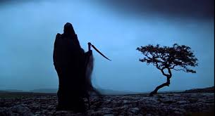

Practice Piece

This is an fragment inspired by the Think Freedom Psi-fi Series
NAT ROLLED QUICKLY back upright, muttering under his breath. “Shit, there’s got to be an easier way of psychoporting than this. Are you OK, Debs?”
“Yeah, I’m fine. Why can’t you land on your feet like me? Why do you always land on your backside every time?”
“I wish I knew. I don’t do it deliberately, I assure you. It’s got to be something to do with my sense of balance or lack of it. I’ll just have to keep choosing places with thick carpets or beds, otherwise I’ll finish up breaking something. Did it work this time?”
“By the feel of it, yes. I’ve still got my nice big stick, if that’s what you mean. It feels pretty substantial to me. Do you want me to try hitting you with it?”
“No, there’s a less painful way than that. Put it down a minute and let’s just see if our proper clothes have come with us.”
As he spoke Nat began pulling his T-shirt off, something that till now had been impossible when psychoporting.
“Hey, it came off and I’m all skin and bone underneath. Kick your shoes off. Let’s see if it’s worked for you, too.” Debbie obliged.
“Now that’s what I call progress. If we can still switch from solid to transient, it’ll be a huge advantage. Let’s see if you can touch my hand––no, Nat, my hand, not my boobs. You’ve got a one track mind.”
Debbie held out her hand as if for a handshake. Nat took it and pulled her into his arms.
“You feel all woman to me, Debs. That’s the way I like you. Hey, what did you do that for?”
As he tried to give her a celebratory smooch, Debbie switched consciously to transient and he was left clutching at thin air as she slipped out of reach with a mischievous giggle.
“We’re supposed to be working, Lover Boy. Don’t forget, Mick and Judie are monitoring what we’re doing. So, the answer to that is, yes, we can. That’s great. This is going to make life so much easier when we’re out and about this way.
“What about our clothes, though. I can’t see your sweatshirt. Where did you put it?”
“It’s on the table right in front of you. Can’t you see it?”
“No, I can’t. Put it back on and let’s see if I can see it then.”
Nat picked up his discarded shirt and pulled it back over his head. As he did, Debbie watched it reappear.
“That’s weird. Take it off again and try giving it to me.”
Nat pulled it off again and handed it to Debbie. This time she could see and feel it as normal. She put it back on the table. Once again it disappeared.
“Can you still see it, Nat? I can’t.”
“Well as long as one of us can, I suppose that’s OK. It might prove difficult if a solid could grab us by our clothing when we’re in avatar form. Perhaps it’s just as well it’s only solid to us. Can you still see your shoes, because I can’t – nor the stick, for that matter.”
“Yes, I can see them both.” Debbie slipped her feet into the comfortable flatties she wore around the labs. She wiggled a pretty ankle at her husband of a couple of weeks.
“Can you see them now?”
“That’s extraordinary. We’ll have to think about this. It could prove a dead giveaway, if we’re not careful––hadn’t thought of that. It’s handy to be able to take objects we need with us when we psychoport but we don’t want to leave them lying around when we disappear again, do we?”
Debbie picked up her stick. “Now that’s no bad thing, is it? I can see my weapon but no one else can, if I happen to drop it.”
**********
Back in the Experimental Psychology Lab Michael Porter and his partner, Judie, were monitoring what Nat and Debbie were doing, both in their telepathic mind’s eye and on the instruments attached to their colleagues' physical bodies, apparently asleep on the pair of lab divans, equipped with all the very latest medical non-invasive patient care systems.
It had taken some hard talking to persuade Sir Eugene Petrov, the third generation son of a Russian billionaire émigré to fund them. When he saw what they could do and realised the potential of their discoveries, his backing was both enthusiastic and unstinting.
“I can well understand why your university research grant was withdrawn. If the ethics people got a sight of what you were doing they’d have thrown a fit. What persuaded you to take off on your own?”
“Exactly that – the uni’s Research Ethics Committee couldn’t see any further than the end of their noses. All they could think of was the university being accused of supporting fakery and witchcraft, if what we were doing got out. You know how the press is always sniffing around our research labs, hoping for a scoop on anything vaguely dodgy. We weren’t as far down the line then as we are now. We’d only just learnt how to switch on our telepathic skill and use it to perfect the telekinetic skills we’ve just shown you. We hadn’t published any papers – nothing. That’s really why they pulled the plug on us. We didn’t dare demonstrate anything to that lot.
“When the four of us found we could project ourselves wherever we wanted – become flies on the wall so to speak – we decided to close the research project down voluntarily, rather than wait for the REC to do it for us. As it was, we still had to face some pretty po-faced interviews with the Chancellor and governing body before we could convince them we’d drawn a blank.
“Naturally we didn’t tell them we were going to carry on under our own steam. Between us we’ve already invested in just enough computer power to run our dedicated AI-controlled system. It’s brilliant––better than anything they’ve got. Once on our own, it wasn’t too difficult to set up our own private lab in Nat’s cellar. He’s got a big old pile he inherited from his grandparents a year or two back. Now we need access to the sort of money you can lay your hands on so that we can go public––preferably global.”
“Are you sure you want to do that? Surely you can see that the sort of skills you’re developing could prove a godsend to the underworld? I hate to think what would happen if some of the crooks and perverts out there got hold of this––what do you call it––psychoporting?”
“That’s the problem. On our own we haven’t got the clout it’s going to take to put all the safeguards we think are necessary in place. I can show you our thoughts on that but no one’s going to listen to us. With your name and the prestige that comes with it we could stand a chance. If you’re prepared to set up a well-funded institute with your brand name on it, you can pull all the necessary strings while we carry on with our R&D to make what we’re doing safe.
“What we are proposing is no more nor less than a plausible cover operation that will allow us to work in absolute secrecy without interference until we’re ready to publish. We need at least a couple of years for that.
**********
That had been two years ago. Now the four brilliant friends were working together in a smart, purpose-built laboratory, tucked away in the Kent countryside, away from prying eyes. On the face of it, it was a new exploratory pharmaceuticals laboratory Eugene Petrov Avionics was using to develop advanced fuel cells for his eponymous fleet of HOTOL aircraft that had already revolutionised global travel, knocking hours off travel times between the continents. Since all four of them––and now Sir Eugene himself––could psychoport around the globe (and, indeed, up to his recently commissioned Moon Labs) virtually instantaneously, what they were doing was not totally unrelated to his business objectives.
The computing power they now had was phenomenal. There were few facilities outside the EPA multinational-organisation that could match its world-class quantum supercomputer using neural networking architecture and software that took advantage of the very latest developments in entangled particle theory. It had taken years to get round the necessity to supercool for stabilisation but EPA materials labs, working on heat-resistant metals for their HOTOL aircraft engines in their space-based laboratories had––almost by accident––discovered a wholly artificial superconducting alloy that could only be produced in sufficient quantity for practical purposes in the guaranteed vacuum conditions not replicable on earth.
Supercomputing had advantages and disadvantages. To take full advantage of its power, all the company’s principals had had to undergo a degree of ‘adaptation’ to allow them full access to the computer 24/7. The advent of smart cellphones in the early 21st century had shown just how invasive even such crude communications technology could be, ruining lives and relationships by getting users as hooked on their usage as the worst Class A drugs available in those days. Now the whole-body health sensor suite built into their brain activity sensor package made sure its élite subjects could not overdo exposure to the technology, monitoring mental stress levels alongside every conceivable physical sympton.
**********
“OK, Mike. It looks as if we’ve cracked the business of taking the things we need with us when we PP. That’s going to make life easier all round. The fact we can see what we’ve taken with us and others can’t could prove a bit of a two-edged weapon, but I’m not too worried about it. It’ll certainly help us sell what we’re doing to the emergency services. They need tools with them to do their jobs, whether they’re soldiers, police or medics, or anyone else you can think of. What do you think?”
“I reckon we’re just about ready to go public. Eugene’s getting twitchy. He wants us to lay on a demo to an invited audience at government level and have our papers ready for publication as soon as he gets the go-ahead. He reckons he’s got all the protocol protection we need in place internationally. He says the UN Artificial Intelligence Regulatory Body is getting suspicious, because he’s been pushing them so hard. The people he’s been talking to can’t see what the hurry is, when there’s nothing on the horizon to suggest there’s any imminent danger of this sort of thing taking off any time soon.”
“Well, the fact that Debs and I were able to bring those books on the table back from our own library, should be enough to convince anybody of how easy it would be for any skilled PP user to pull off the perfect crime. If we can’t keep our discoveries out of the hands of the bad guys, we daren’t go public. It would be like releasing the plague all over again.”
“Exactly, Nat. We know what’s possible. We also know––or think we know––no one else is even close to doing what we do. Conventional medical research has concentrated on developing almost undetectable prostheses for the seriously disabled, perfecting nerve connections and that sort of thing. Now they’re beginning to make headway in interpreting thought processes into speech. They’re already helping people who’ve had the full use of the gift of language. They’re not so clever with people who’ve been living like vegetables all their lives.”
Judie chipped in: “Progress in our sphere of things has been abysmally slow. It was back in ’14 when those guys in India demonstrated they could use brain stimulation equipment to prove telepathy isn’t a figment of the sci-fi imagination. Here we are in the nineties and we’re the only ones to our knowledge who’ve cracked the problem of turning it into a reality. They fell at the first hurdle. As soon as the press started to sneer at them they dropped it. No, I’m pretty certain we’re way ahead of the competition. In fact, I’m not sure there is any competition.”
“You’ve always been a glass-half-full person, Jude, I’ll say that for you. I think, if we’ve got as far as we have and managed to keep it under wraps, there’s almost bound to be others out there.”
“Don’t be such a pessimist, Debs. Let’s get these demos the boss wants worked out. Our papers are as ready for publication as they‘ll ever be. If that doesn’t flush the competition out into the open, I reckon it doesn’t exist. I’m convinced we’ll have a clear field to put all the benefits we’ve dreamed of into place. With a man like Eugene behind us, we ought to have training sessions up and running in the next twelve months. Let’s face it, our AI trainers are all ready to go. We’ve got a good, fully committed team working with us. I haven’t detected a trace of disloyalty in any of them. It isn’t as if they could hide anything from us even if they wanted to.”
**********
It wasn’t just a case of psychoporting anymore but telepathy was the key to everything they could now do. They had proven to their own satisfaction that there were degrees of skill in its use. So far they hadn’t found anyone who could approach their own level, not even their generous sponsor, although they weren’t about to tell him that. Their definition of a truly skilled telepath was one who could read anyone’s mind without fear of detection. Such an expert could effectively block a lesser telepath’s attempts to mindread.
You didn’t need to be at the top of the telepathy tree to be able to use the gifts that went with it but it helped. The first of these skills, telekinesis––the ability to move objects by the power of thought––was relatively easy to pick up. Their study of examples of poltergeists through the ages convinced them that human thought was behind the projectiles thrown at victims, so often an unfortunate nurse or mother at their wit’s end with a destructively precocious child.
With a bit of lateral thinking, it was Debbie who had come up with the trigger that allowed her to project a screwed up ball of paper at Nat’s head just by thinking about it, when he was being particularly obtuse one evening after a hard day of repeated failure to achieve anything. The couple kept it to themselves until they had perfected the art of pouring a cup of tea from a pot and passing it to a guest with no hands. It took a few headaches before they managed to lift a full teapot by thought alone but their almost childlike pride in the achievement was soon shared with their friends.
Progress to psychoporting––or PP as they soon started calling it––came by accident rather than design. They had all long since agreed that being able to move around at will even in a detached form like that described by shamans (and shysters) over the centuries had to be the ultimate goal of their research. When Mike made his first ‘excursion’ he wasn’t at all sure what had happened or how he’d done it. The trigger seemed to have been the gentle buzz of his comms ‘implant’ announcing an incoming call from Nat just as he was waking up. The next thing he knew he was standing in Nat’s bedroom, gazing at the delightful vision of a languid, nude Debbie reclining on the bed reading a magazine.
When he spoke to Nat, who was clearly expecting to connect with Mike on his hand-held comms pad, he nearly jumped out of his skin. Debbie yanked at the bedcovers in a desperate attempt to hide her nakedness. They were both looking around frantically to see where his voice was coming from. Clearly they couldn’t see him.
Mike grinned to himself. The friends weren’t into wife-swapping but he had to admit Debbie’s charms weren’t lost on him. He ‘walked’ over to the window and pulled back the curtain, making both of his friends turn sharply towards the noise. Obviously they still couldn’t see him. He walked over to Debbie’s dressing table and pulled out the chair to sit down. It felt perfectly solid to him and he could see his own pyjama-clad body perfectly clearly, even if they couldn’t.
“Is this some kind of practical joke, Mike Steer? How did you get into our bedroom without us seeing you? Come out, wherever you are and stop your silly tricks.”
“I don’t know how I got here myself, Nat. One second I was just thinking about getting up, when your call alert went off in my head. The next thing I knew I was standing at the end of your bed with a delightful view of Debs to make my day.”
“Pig! Get out of my bedroom at once. I’ll have words with Judie about this.”
“I didn’t do anything on purpose, Debs. I’m sorry. Somehow or other your call, Nat, has transported me from my bedroom to yours. I can see you but you can’t see me, although I can see myself. Anyway, what did you want at this time in the morning?”
“Whatever it was can wait. You’ve driven it out of my head anyway. I think you’d better get back to your house and see if Judie’s missed you. Is she up?”
“Since I’ve no idea how I got here, I’ve no idea how I get back. Do I just think myself back home?”
With that Mike found himself back in his own bedroom but ‘he’ was still lying on the bed, looking rather vacant. Judie was, thankfully, still asleep. He wondered if he could use his comms implant to call Nat and Debs. The thought triggered the call, just as it would if he were in his physical form. He noticed there was no reaction from his body, when Nat came through almost immediately.
“Are you back where you ought to be, Mike?”
“Well, yes and no. I’m back home in my own bedroom but the real me is still lying on the bed where I left him. Now, I’ve got to work out how I get back in there.”
Once again, the thought was mother to the deed.
“Jeez, that’s a relief. I’m solid again. At least I won’t put the fear of God into Judie when she wakes up beside an inanimate me. Look, I’m going to have a shower and do some serious thinking. I’ll see you in the lab at nine. Perhaps by then I’ll have some answers.
By the time they met, Mike had worked out that to get into PP mode he had to be actively in both telepathy and telekinesis mode and––as in all this stuff––he needed a specific trigger to be able to ‘fly’, not just the desire to do so. He submitted to the brain scan procedure they had adopted to enable them to identify the active nodes at the moment of ‘take-off’. It was the breakthrough they had all been waiting for.
The AI took the results and––extrapolating from their recent work far faster than any human brain could––switched the device to active and announced in the smug voice it used when it knew it had out-performed its designers that it had devised a simple process to enable it to convert all of them so that they could fly with ease and without ill effect.
In their early experimentation they discovered that an adept telepath could always detect a ‘flier’, identify him and repel an unwanted presence. This satisfied their constant search to make their work secure and ethical.
“It’s all very well being able to fly around in invisible form. Fine if all you want to be is a fly on the wall in secret, but don’t you think it would be even more useful to be able to visit people in a solid, visible form? We don’t want to be accused of only developing methods of deceiving people, do we?”
Judie was in righteous mode.
“I can imagine all sorts of uses for fliers being sent out to help in difficult situations, where they would need to be in solid form so as not to spook the natives.”
“What sort of situations do you mean, Jude?”
“Oh, come on, Debs. There must be all sorts of scenarios where time is of the essence and it would be useful to to dispatch experts to help. Just think of any serious accident scene, when casualties would be dead before even a heli-ambulance could get there.”
“Of course you’re right, Jude. The medics or whoever wouldn’t be much use if no one could see them and they didn’t have the tools of their trade. All we need to do now is turn our fliers into some kind of avatar that everyone can see and relate to. Any bright ideas?”
“You’re the ideas man on this one, Mike. You were our first flier––all you’ve got to do now is devise a way to ‘appear’ wherever you’re flying to and preferably be able to take a first aid box or a gun or whatever you need with you.”
“Yeah! Easy-peasy! Well, it just so happens that one of our researchers has got a theory he wants to try this morning. He reckons when we fly we have to generate some sort of aura that takes our conscious self wherever we want to go. That’s got to be true, if a telepath in the target area can identify the flier. Now all we’ve got to do is identify a method of giving that aura substance. Simplicity itself––what are we waiting for?”
“Has your researcher got any more bright ideas?”
“No, Nat, he hasn’t yet––or he didn’t have when I last spoke to him.”
**********
Jock Hamilton was right. With only minor adjustment the lab advanced metrology suite was able to identify his aura when Mike volunteered to fly in the confines of the laboratory. Following Jock’s directions, he walked over to the lab bench where the others were all gathered looking at the computer screen. Mike’s body was visible on screen in glowing outline.
“Pick up that little box in front of the screen, Mike, and put it in your pocket.”
Mystified, Mike did as he was bid and to everyone’s amazement instantly appeared alongside them.
“How the hell did you do that?”
“Simple. If we can detect the aura, then there has to be energy we can utilise. Using holographic illumination it’s simplicity itself to paint it with an active image of its origin – in this case Mike. What I just gave you, Mike, is a mini holo-projector. Now we can see you and hopefully you’ll be able to decide if we can or we can’t at will. I’ve patched it in to your control program, so you should be able to think it on and off.”
By the end of the day’s experimentation they had discovered that the ‘holographic’ flier image had its limitations. He couldn’t, for instance, change his appearance. What he was wearing at ‘take-off’ was what he was stuck with. While the flier could touch and move things, the people he was appearing to couldn’t touch him – an advantage in a hostile situation, perhaps, but none too convincing, if people simply wanted to shake hands. More work was needed.
Within the week, the problem was solved, which is where we came in.
**********
The launch of the EPA new venture went out to the world in a blaze of publicity. Eugene Petrov was no shrinking violet. The team’s scientific papers were published simultaneously, with peer reviews, obtained under conditions of the utmost secrecy, that ensured praise of the highest order from all over the world and all quarters, not just the academic sphere. Indeed, it was from that quarter that the team had expected the greatest resistance, but it was clear that ‘the boss’ had been using his huge global influence to silence the nay-sayers.
What was demonstrated to the public had to be limited. Accusations of smoke and mirrors trickery would close down the project before the day was out. Mind reading and mind bending had always been subjects of huge mistrust. Anything that smacked of confidence trickery would only draw scorn – possibly even prosecution for attempted fraud. Any hint that they were playing on public fears and superstitions would bring only contempt.
What the team had to achieve from the outset was to convince their invited audience of the huge benefits that could be derived from putting their new psycho-techniques to work. The vehicle they chose to do this was the jewel in their development, the focus of their studies for the past two years, when they had realised that only a spectacular demonstration of remote healing techniques would satisfy the world that they were not charlatans.
Debbie, originally an orthopaedic surgeon, was behind their most serious line of research after the basics of telepathy, telekinesis and flying had been mastered. She was determined to investigate one of the most documented ‘supernatural’ powers – healing by the laying on of hands. Examples were still guaranteed to hit the headlines periodically, even in the most sceptical of media publications.
Early in their research she had enlisted the help of Judie, a top psychologist who had dabbled in surgery, in arguing the case for investigating the practical truth behind seemingly miraculous cures of the ‘take up thy bed and walk’ genre. Judie discovered she could not only lift, but also manhandle her reluctant husband using her psychokinetic ability. In short order, they all learnt how to inflict pain remotely by deforming muscles or twisting bones and sinews.
Discussing her private success with Debbie, she triggered her interest in what might be possible in bodily repair work, without the need for invasive surgery. Between them they persuaded a friendly local vet to allow Debbie to assist at emergency operations. To say that the poor man was flabbergasted by her ability to re-set broken bones perfectly without surgery would be an understatement. When he realised she was doing it without anaesthetics and yet causing no pain, he began to wonder if she was a real live witch. Corby Jennings became their second convert after Eugene Petrov.

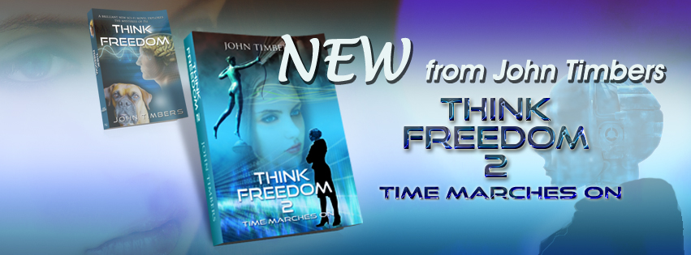

Because of the WW2 hulks, part of the Mulberry Harbour on the Normandy beaches, that had been left there.
“Physics of the Impossible” by Michio Kaku – an excellent read

